# Visual Studio Lessons Learned

Table of Contents

Visual Studio Lessons Learned 1

If you get an error mentioning chmod 1

If you get an error saying that there are 2 versions of certain things in different files 1

If you have problems with SpecFlow not working properly 1

Cannot find custom tool 'SpecFlowSingleFileGenerator' 2

**Troubleshooting Visual Studio Integration** 2

Enable Extension 2

If you get an error saying that access is denied to chromedriver 3

If you get an expected: #EOF error in Specflow 3

If you have permissions error when doing first commit on new repository 4

## If you get an error mentioning chmod

If you get an error mentioning chmod when you try to build, this is something to do with access, probably with Visual Studio no releasing locks on some files. This can be sorted by restarting Visual Studio, BUT wait several minutes before attempting again. If you try to open Visual Studio again too soon then the problem will still be there.

## If you get an error saying that there are 2 versions of certain things in different files

If you get an error saying that there are 2 versions of certain things in different files (e.g. Webdriver Wait being in Selenium and Selenium.Support) then first try rebuilding the solution and restarting Visual Studio. If this does not work then you will need to delete all the files on your C: drive from the folder containing the tests downwards (basically delete your test framework). Then go to Team Explorer -> Source Control Explorer and Get Latest for the files you deleted (you can Get Latest from a higher level if that works better with your mapping).

## If you have problems with SpecFlow not working properly

Go to Tools->Extensions and Updates-Installled

If SpecFlow for Visual Studio <version> is installed already, uninstall it.

Go to Online

Search for SpecFlow for Visual Studio and install it.

Might be worth restarting Visual Studio afterwards

Another thing to try is:

**SpecFlow creates a .cache file in your Temp folder** that holds these bindings to speed things up. If that file gets out of whack, you can **delete it**:

1. Exit Visual Studio.
2. Open Windows Explorer.
3. In the address bar, type %TEMP% and hit Enter to go to your temp folder.
4. Find the files whose names start with "specflow-stepmap-YourProjectName" with a .cache extension.
5. Delete those files.
6. Start Visual Studio again.

If you do this, it'll take a little time for SpecFlow to regenerate the bindings. Until this is done, if you right-click on a step and select "Go To Step Definition", Visual Studio will reply "Step bindings are still being analyzed. Please wait."

I most commonly use this for the opposite case, where SpecFlow shows that *nothing* is bound even though the steps exist. But I think it's likely to work for your case as well.

## Cannot find custom tool 'SpecFlowSingleFileGenerator'

NOTE: I do not think that this applies for .NET Core (Specflow V3.0) since other instructions tell you to remove the custom tool from properties

<https://specflow.org/documentation/Generate-Tests-from-MsBuild/>

If you cannot get specflow to recognise changes to a feature (e.g. tests removed, new feature file created) then it could be that the Custom Tool has been disabled. In which case, follow these instructions.

# **Troubleshooting Visual Studio Integration**

Mykhailo Vinichenko edited this page 2 days ago · [16 revisions](https://github.com/techtalk/SpecFlow/wiki/Troubleshooting-Visual-Studio-Integration/_history)

## Enable Extension

If Visual Studio displays the error message Cannot find custom tool 'SpecFlowSingleFileGenerator' on this system. when right-clicking on a feature file and selecting Run Custom Tool, make sure the SpecFlow extension is enabled.

To enable the extension in Visual Studio, select **Tools | Extensions and Updates...**, select the "SpecFlow for Visual Studio" extension, then select **Enable**.

If the error still occurs, select **Tools | Options | SpecFlow** and set **Enable SpecFlowSingleFileGenerator Custom Tool** to 'True'.

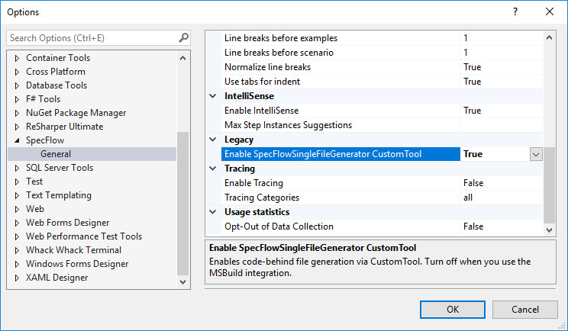

## If you get an error saying that access is denied to chromedriver

This is because you have too many instances of chromedriver running. This is caused when the driver has not shut down properly, most likely due to debugging and stopping the test before the end (where it would runt Teardown and close the driver.)

Go to Task Manager and end all the chromedriver processes. The rebuild again.

## If you get an expected: #EOF error in Specflow

If you get an error like this, then you are likely to be missing ‘Outline’ in the first line of a scenario with Examples. The first line that uses an examples table should look something like this:

Scenario: Invalid Login - Empty email and valid password

#error: '(66:1): expected: #EOF, #TableRow, #DocStringSeparator, #StepLine, #TagLine, #ScenarioLine, #ScenarioOutlineLine, #Comment, #Empty, got 'Examples:'' Portal.Web.AcceptanceTests C:\Users\gmacdona\Source\Workspaces\UK\Portal\Main\Source\Portal.Web.AcceptanceTests\Features\Common\Login.feature.cs 1 N/A

## If you have permissions error when doing first commit on new repository

This is caused by not having a gitignore file set up with the .vs folder added to it.

Solve it by going to Team Explorer – Settings-Repository Settings

Ignore File section

Add

.vs should already be added to the gitignore file by default

<https://stackoverflow.com/questions/47460039/vs-2017-git-local-commit-db-lock-error-on-every-commit/47472811>